BAZA DE DATE CINEMATOGRAFE ROMANIA

# ERD

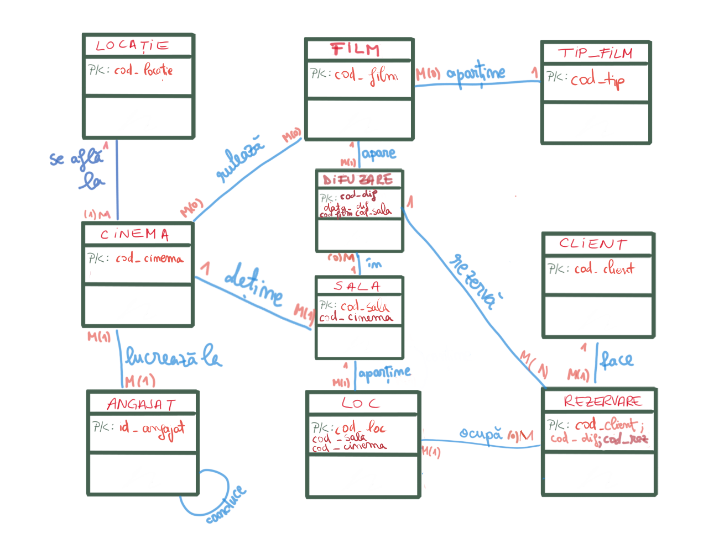



Diagrama Conceptuala

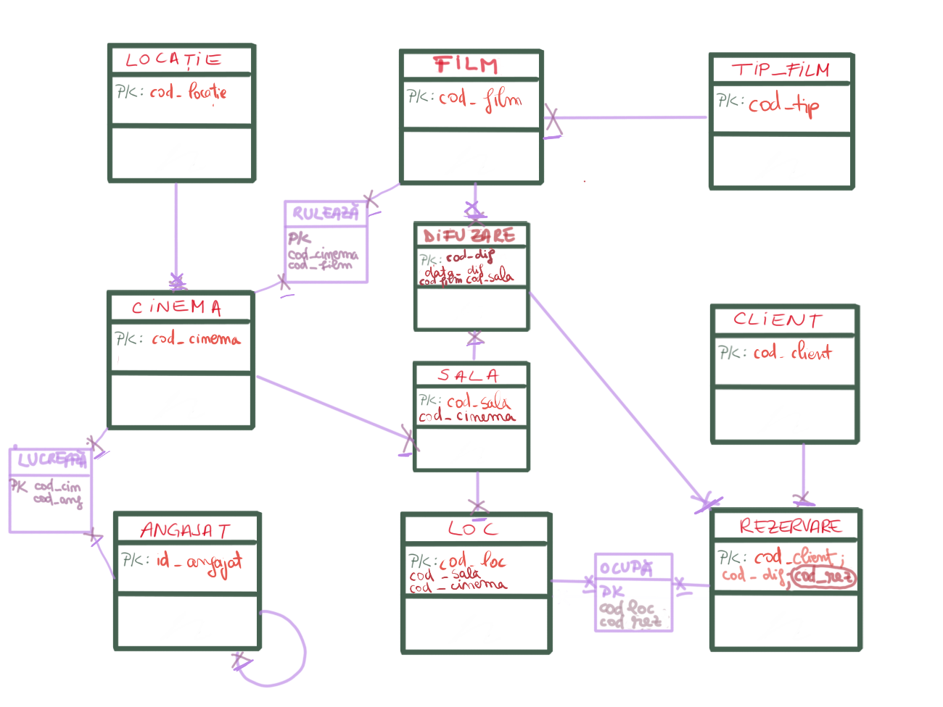

## SCHEMELE RELATIONALE

**TABEL INDEPENDENT**

CREATE TABLE **CLIENT**

(

Cod_client NUMBER(5) **PRIMARY KEY**,

Nume VARCHAR2(25),

Prenume VARCHAR2(25),

Telefon NUMBER(10),

Varsta NUMBER(2)

);

**TABEL DEPENDENT**

CREATE TABLE **CINEMA**

(

Cod_cinema NUMBER(4) PRIMARY KEY,

Cod_locatie NUMBER(4) FOREIGN KEY, refrences **LOCATIE** (cod locatie)

Nume_cinema VARCHAR(25),

);

**TABEL ASOCIATIV**

CREATE TABLE **LUCREAZA**

(

Cod_angajat NUMBER(4),

Cod_cinema NUMBER(4),

Data_inceput DATE,

PRIMARY KEY (cod_angajat, cod_cinema,data_inceput), refrences ANGAJAT(cod_angajat), CINEMA (cod_cinema)

);